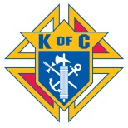 The Annual Parish
Father Daughter Dinner Dance
Presented this year at no cost to you
by Father Veger Council 5561

Mercy Hall
Saturday, May 11, 2019
6:00pm – 9:00pm

Dine and Dance with your Little Princesses
Enjoy a Night to remember…in Candyland!

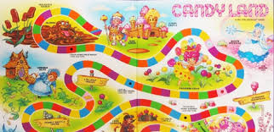

Join us for Fun, Food, and Great Music!

Doll Raffle to benefit KOVAR
FREE Admission for all Dads and Daughters!!
POC: Ed Cook 540-349-9203, ecook0@gmail.com

